**ESME Workbench 2011**

**Effects of Sound on the Marine Environment**

****

**User Guide**

**April 11, 2011**

Produced by:

*Biomimetica ESME team:*

Dorian Houser (dhouser@spawar.navy.mil), Principal Investigator

Matt Cross (mattsnail@cox.net), Programmer

*Heat Light and Sound Research ESME team:*

Michael Porter (michael.porter@hlsresearch.com)

*Boston University ESME team:*

David Mountain (dcm@bu.edu), Principal Investigator

David Anderson (da@bu.edu), Software lead

Viktor Vajda, (dvajda@bu.edu)User Interface design and coding

*Portland State University ESME team:*

Martin Siderius (siderius@pdx.edu)

Scott Schecklman (ssheck@pdx.edu)

Table of Contents

[Chapter 1: Introduction 3](#_Toc289864563)

[Propagation Models 3](#_Toc289864564)

[Sound Sources 4](#_Toc289864565)

[Marine Mammals 4](#_Toc289864566)

[Take Calculations 4](#_Toc289864567)

[User guide 5](#_Toc289864568)

[Chapter 2: ESME Workbench Installation 6](#_Toc289864569)

[Creating a Local Directory Structure 6](#_Toc289864570)

[Installing ESME 6](#_Toc289864571)

[Supplemental ESME Files 6](#_Toc289864572)

[Scenario Builder 7](#_Toc289864573)

[OAML Databases 7](#_Toc289864574)

[Chapter 3: Introduction to the ESME Workbench 9](#_Toc289864575)

[ESME Workbench GUI 9](#_Toc289864576)

[Menu Bars 9](#_Toc289864577)

[Map Window Controls 10](#_Toc289864578)

[Map Layer Controls 10](#_Toc289864579)

[Applications Menu 10](#_Toc289864580)

[Defining ESME Options 10](#_Toc289864581)

[Experiment File Name 12](#_Toc289864582)

[ESME Functionality 13](#_Toc289864583)

[ESME Overview 13](#_Toc289864584)

[Creating an Experiment 14](#_Toc289864585)

[Running a Transmission Loss Analysis 15](#_Toc289864586)

[Running an Animat Scenario 16](#_Toc289864587)

[Chapter 4: Example Experiment 17](#_Toc289864588)

[Load a scenario file 17](#_Toc289864589)

[Create an Experiment File Name 18](#_Toc289864590)

[Load an animal population from 3MB 18](#_Toc289864591)

[Bibliography 30](#_Toc289864592)

# Chapter 1: Introduction

Concern about the impact of sound on marine mammals has increased over the past decade causing governments to take a more rigorous look at the potential impact of activities that introduce sound into the marine environment. The National Environmental Policy Act (NEPA) [42 U.S.C. 4321 et seq.] requires that all major federal actions conducted by the United States (U.S.) government consider the potential impact of the proposed action on the environment. When significant impacts to the environment are anticipated, or when there is significant public or scientific controversy over the impact of the proposed action, federal agencies are required to perform detailed assessments of the potential impact in an environmental impact statement (EIS).

The accuracy of an EIS for acoustic activity in the marine environment depends on robust computer simulations involving multiple sound sources and marine mammal species, moving in a 3D environment. Furthermore, propagation of underwater sound waves is often a complicated function of a number of environmental factors. Reflection and refraction of sound waves is strongly dependent on a number of ocean and sediment properties, and may result in localized high-intensity convergence zones and/or surface ducts. In an effort to anticipate the effects of sonar on marine mammals, the U.S. Navy currently uses a number of separate, *proprietary* programs to simulate acoustic propagation and then calculate the number of animals affected by Naval training exercises in the ocean.

The purpose of the ESME Workbench is to link several *open-source* programs and environmental databases together via a single graphical user interface (GUI) which can be used by anyone in the scientific research community. External programs for modeling propagation and marine mammal behavior are automatically installed with the ESME Workbench. Environmental databases are downloaded separately, and linked to the workbench by the user. The workbench computes propagation and mammal movement in four dimensions (3D space and time) to compute the exposure level for simulated animals, called “animats”. The exposure levels are compared with federally established thresholds and reports are automatically generated to estimate the number of mammals that would be affected. The ESME Workbench is currently configured to simulate sound exposure due to Naval training exercises, but can be modified to include other anthropogenic activities, such as oil exploration or pile driving.

## Propagation Models

Four propagation models are included in the ESME Workbench. **Bellhop** is a ray-tracing model that can quickly calculate TL in ocean environments that are many wavelengths deep (Porter 1987). The Comprehensive Acoustic System Simulation / Gaussian Ray Bundle **(CASS/GRAB**) model is a ray-tracing tool used by the U.S. Navy (Keenan 2000). The Range-dependent Acoustic Model (**RAM**) uses the Parabolic Equation (PE) to calculate TL in areas with range-dependent propagation properties and/or multiple layers of sediment (Collins 1996). Reflection and Refraction in Multi-Layered Ocean/Ocean Bottoms with Shear Wave Effects (**REFMS**) is a tool that can be used to simulate the propagation of shock waves from an underwater explosive charge.

Each of the propagation models in the ESME Workbench accesses environmental databases which store bathymetry and other acoustic parameters (sound speed in the ocean and sediment layers, wind velocity, etc). The models compute transmission loss (TL) in 2D grids of range and depth along transects extending outward from the source position. The user can configure the transect size and spacing, as well as the range and depth increments to be used in the calculations. ESME automatically runs a propagation model for each transect and then interpolates TL for points between them.

## Sound Sources

Sound pressure level (SPL) at every point in the simulation space is determined by adding the source level (in dB: re 1μPa) to the TL. The Naval Undersea Warfare Center *(*NUWC) developed NEMO as an application to model naval sound source platforms and marine mammal distributions. The ESME Workbench currently uses NEMO’s sound source database to specify naval platforms. A wide variety of Navy sonar platforms, sources and ship tracks can be defined. The ESME Workbench does not use the marine mammal distribution settings in NEMO.

## Marine Mammals

The ESME Workbench defines animal locations using 3MB, from BIOMIMETICA. Within 3MB, the 3 dimensional movements of artificial animals (“animats”) can be defined using a number of species-dependent behavior settings . The SPL at each point along an animat’s dive path is used to calculate its maximum SPL exposure as well as its total sound energy level (SEL) exposure. These values can then be compared with acoustic thresholds to estimate the number of marine mammals that would be affected by the sound.

## Take Calculations

The ESME Workbench uses auditory thresholds to determine the number of mammals that will be affected, or “taken”. For odontocete cetaceans (toothed whales), the U.S. Navy currently implements three sets of criteria and thresholds for estimating Level A and Level B harassment resulting from exposure to MFA sources . The criterion for a Level A take is considered to be the onset of Permanent Threshold Shift (PTS), or a permanent reduction in hearing sensitivity. Two criteria exist for Level B takes. The first criterion is the onset of a Temporary Threshold Shift (TTS), or a temporary reduction in hearing sensitivity. The second criterion is a behavioral response, in the absence of auditory fatigue, which is a significant alteration of a species' normal behavioral patterns.

Thresholds for harassment determined by the onset of PTS and TTS are based on the sound exposure level (dB re: 1 µPa2 s) of an animal accumulated over the duration of an exercise. Sound exposure level is defined as,

$SEL=10 \log_{10}\left(\frac{\int_{0}^{T}{p^{2}(t)dt}}{P_{ref}^{2}T_{ref}}\right)$ (1)

where Pref = 1 µPa and Tref = 1 s. Level B harassment due to a behavioral alteration (i.e. in the absence of auditory fatigue) occurs when the maximum sound pressure level (SPL) received over the duration of the exercise is great enough to cause the mammal to significantly alter its normal behavioral patterns. Sound pressure level is defined in terms of the root-mean-squared pressure field P as,

$SPL=10 \log_{10}\left(\frac{P_{rms}^{2}}{P_{ref}^{2}}\right)$ (2)

The number of harassments estimated to occur from an exercise is calculated by evaluating a risk function (defined in Appendix J of the HRC EIS) that relates the risk of harassment to the maximum sound pressure level received by a marine mammal . The risk function varies between 0 (no risk) and 1 (maximum risk) and can be interpreted as the probability that an individual may alter its behavior in response to a given maximum SPL. The risk, R, is given by

$R=\frac{{\left(\frac{L-B}{K}\right)}^{A}}{{1+\left(\frac{L-B}{K}\right)}^{A}}$ (3)

where L is the maximum received SPL level (dB). The basement value, B, is 120 dB, and K is set to 45 dB so that a received level of 165 dB corresponds to a 50 % probability of harassment. We note that the algebraic form of the risk function in the literature has been recast into the form shown in Equation 3 in order to avoid a divide-by-zero error that would occur in the original formula when L - B = K. The risk transition sharpness parameter, A, depends on the marine mammal classification. For all odontocetes (toothed whales, dolphins and porpoises), except the harbor porpoise (*Phocoena phocoena*), A = 10. (The harbor porpoise is given special consideration as a particularly sensitive species.) The risk function for odontocetes is plotted in Figure Fig. 1.

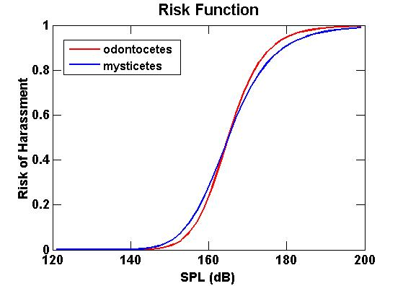

When the maximum received SPL is near 120 dB, the risk of harassment is low. The risk rises sharply as the maximum received SPL approaches 160 dB and reaches a maximum value of 1 when the maximum received SPL is 195 dB.

The ESME Workbench calculates the number of animats taken during a simulation. A spreadsheet report summarizes the number of each species that exceeded each of the three take thresholds described above.

## User guide

The ESME Workbench user guide is intended to help new users set up and run simulations, called “experiments”. Chapter 2 describes how set up the directory structure for the ESME Workbench. It provides detailed instructions for downloading and installing the main program, as well as the supplemental databases needed to run simulations. Chapter 3 guides the user through the initial startup of the ESME Workbench. It highlights the layout of the main components in the GUI and defines some of the terminology used in subsequent discussions. Instructions are given to link the ESME Workbench with the supplemental databases and programs, and flow charts illustrate the basic steps necessary to create and run an experiment. Finally, chapter 4 provides a detailed step-by-step example experiment to demonstrate the capabilities of the ESME Workbench.

# Chapter 2: ESME Workbench Installation

This section provides a summary of how to install and set up the ESME Workbench.

Note: The ESME workbench currently requires the Windows 7 operating system.

## Creating a Local Directory Structure

A basic directory structure is suggested to keep the input/output and program files organized when running the ESME Workbench. The directory names and structure listed below are recommended, but not required. These directory names will be used throughout this document.

Create the following directories on the local computer:

* ESME\_program\_files
  + The installation setup file and most of the program files to run ESME will be stored here.
* ESME\_experiments
  + The ESME experiment file (.esme) file for each specific experiment run in the ESME Workbench. The ESME experiment file contains the paths to the input data files and the location of analysis points in the experiment.
  + Folders will also be created in the same directory as the \*.esme file which contain the output files (\*.tlr) from the transmission loss (TL) calculations. (These folders are hidden.)
  + Transect TL data files (.csv) and plots (.png) can be saved here.
  + The results of the scenario analysis (.csv file) can also be saved here.
* OAML\_databases
  + The environment files necessary to run propagation models in ESME will be stored here.
* Scenario\_Builder.
  + The scenario builder executable file (.jar) and all the subdirectories associated with scenario builder.
* 3MB\_data\_files
  + This will store the population distribution (.sce) files generated by 3MB.

## Installing ESME

Download the ESME installation file from the Boston University (BU) website.

<http://esme.bu.edu/team/>

Save the installation setup file ([ESME WorkBench Setup.msi](http://esme.bu.edu/team/Phase%201%20Iteration%204/ESME%20WorkBench%20Setup.msi)) in the ESME\_program\_files directory, described above.

Navigate to ESME\_program\_files directory and run ESME WorkBench Setup.msi. Set the program installation directory to ESME\_program\_files.

It is possible to start the ESME Workbench at this point, but the workbench will require several supplemental files to be downloaded before any simulations can be performed. The following section describes these supplemental files.

## Supplemental ESME Files

The ESME Workbench requires supplemental files to be installed before running simulations. Scenario Builder is an application that defines the sound sources and their locations. The Oceanographic and Atmospheric Master Library (OAML) databases contain environmental files that are used by the propagation models.

### Scenario Builder

Download the Scenario Builder 1.5.508.zip file from the Boston University (BU) website.

<http://esme.bu.edu/team/>

Unzip the compressed folder within the Scenario\_Builder directory, described above.

### OAML Databases

The environmental data used by ESME Workbench to generate transmission losses is provided by four Oceanographic and Atmospheric Master Library (OAML) Databases:

1. The Re-Packed Bottom Sediment Type Database, Version 2.0 (BST)

2. The Digital Bathymetric Database – Variable Resolution, Version 4.5U (DBDB)

3. The Generalized Digital Environmental Model – Variable Resolution , Version 3.0.1 (GDEM-V)

4. The Surface Marine Gridded Climatology Database, Version 2.0 (SMGC)

These databases are available on a variety of compact disc media, and may be provided as part of the ESME Workbench software suite as a collection of compressed files.

Each of the four OAML databases are subtly different and must be configured differently. Each database requires the use of a) a database extraction program and b) the database itself. What follows is a description of both attributes for each database.

1. BST

a. Extraction Program

The BST extraction program is named „extract.exe‟, and is located on the OAML CD at the path

“Sediments2.0\_QAV\_Analysis\Sediments\Version2.0\tools\Windows\with\_hdf5\_1.6\extract.exe”

The extraction program should be copied to disk, and its location configured in the ESME Workbench options dialog.

b. Database structure

The BST Database is provided as a HDF5 file on the OAML CD, “Sediments2.0\_QAV\_Analysis\Sediments\Version2.0\databases\hfevav2.h5” and may be copied locally. Its location is configured in the ESME Workbench options dialog.

2. DBDB

a. Extraction Program

The DBDB extraction program is located on the OAML CD at the path “bin\Windows\dbv5\_command.exe”

b. Database structure

The DBDB Database is provided as a HDF5 file located on the OAML CD at “data\dbdbv5\_level0c\_0.h5” and should be copied locally.

3. GDEM-V

a. Extraction Program

The extraction program for GDEM-V is provided as a standalone application that is bundled with ESME Workbench.

b. Database structure

The GDEM-V database is a collection of gzipped NetCDF files that are provided on 4 CDs. CD 1 contains 12 files named “tgdemv3sXX.nc.gz”, where XX ranges from 00 to 12, and correspond to calendar months JAN-DEC, respectively. ‘T’ denotes ‘ temperature’. CD 2 contains 12 files named “sgdemv3sXX.nc.gz”, where XX again ranges from 00 to 12, and ‘S’ denotes ‘salinity’. These 24 files should be decompressed and placed in a single directory, and the location of this directory specified in ESME Workbench’s Options dialog.

4. SMGC

a. Extraction Program

The source code for the SMGC extraction program is provided on an OAML CD. The compiled version for windows operating systems is provided with ESME Workbench, and is located in the default installation directory, and named SMGC\_Extract.exe.

b. Database structure

The SMGC database consists of 64,800 files of the form “[n,s]XX[e,w]YYY.stt”, where XX specifies the latitude and YYY the longitude, in degrees, of the 1 degree of the globe that that file contains information for.

These files are spread across discs 2-5 of the OAML CDs. They should all be copied into the same directory on the local hard drive, and that directory’s location specified in ESME Workbench.

The following compressed OAML databases can be downloaded from the Boston University (BU) website <http://esme.bu.edu/team/>

BST.zip

DBDBV\_v5.4.zip

GDEM-V.zip

OAML Extraction Tools.zip

SMGC.zip

Unzip the compressed files as sub-directories within OAML\_databases directory on the local computer.

# Chapter 3: Introduction to the ESME Workbench

This chapter guides the user through the initial start up of the ESME Workbench. The graphical user interface (GUI) is briefly described, and options are set to link the supplemental data files and programs. Finally, flow charts are presented to summarize how to set up and run experiments.

## ESME Workbench GUI

This section provides a brief survey of the main ESME Workbench screen and defines some of the terminology used to reference various functions.

From the desktop, double-click on the ESME 2011 shortcut to start the ESME Workbench.

After ESME starts, expand the main window to see the entire screen as shown below.

< File name >

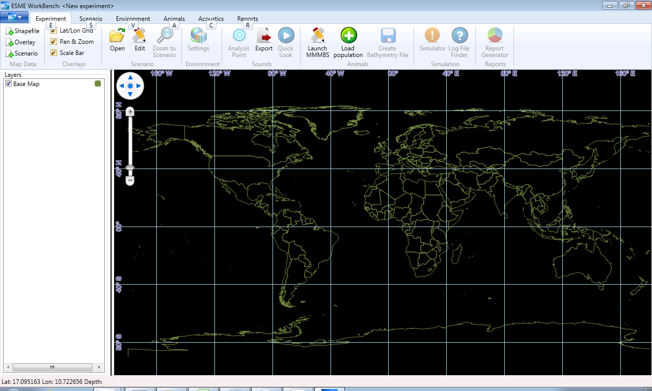

Map window

Layer window

Pan control

Zoom control

Icon Menu Bar

Line Color

Application Menu

Ribbon Bar

### Menu Bars

The “ribbon bar” across the top of the screen contains the applications menu (drop-down box in upper left corner) and six “tabs”. Each tab on the ribbon bar displays a different “icon menu bar” below it. Vertical lines on the icon menu bar divide the icons into “groups”. The icons in the Environments, Acoustics and Reports tabs are not used in this version of the ESME Workbench.

The functionality of each of the menu icons will be demonstrated in an example at the end of the user guide.

### Map Window Controls

The map and layer control windows are below the icon menu. The layers control window is used to set the display options for the data displayed in the map window.

The center position of the map can be changed by clicking on the up/down or left/right arrows of the pan control in the upper left corner of the map. Alternatively, the map center can be adjusted by left-clicking anywhere on the map and dragging the map. Release the left mouse button to stop dragging the map.

The zoom level of the map can be adjusted by sliding the marker on the zoom control up or down. It can also be changed by clicking on the plus or minus sign at the upper or lower ends of the zoom control. If the mouse has a scroll wheel, it can also be used to zoom in and out.

By default, the ESME Workbench shows the pan control, zoom control and latitude and longitude grid lines on the map window. These can be turned off by removing their respective checkmarks in the “Overlays” group of the icon menu, under the “Experiment” tab.

### Map Layer Controls

The layer box contains a list of the layers that can be displayed in the map window. When the ESME Workbench starts, it defaults to a single map layer, called “Base Map”, which shows national boundaries on all of the continents outlined in green. A square color box in the layer control box indicates the color used to outline the Base Map layer. The color and thickness of the lines outlining the countries can be changed by right-clicking on the green square next to the base map in the layer control window. The map background is always black.

The Base Map layer can be turned off by removing the checkmark to the left of the layer name in the layer control window.

Additional layers can be added manually to the map window using the options in the “Map Data” group of the icon menu, under the “Experiment” tab. Typically, layers will be added automatically by the ESME Workbench as a simulation is created and run.

Some layers may have an additional color fill option in the layer control window. This option will be displayed as another colored square to the left of the line-color square. The fill color can be changed by right-clicking on the colored box in the layer control window.

## Applications Menu

The applications menu appears as a blue button with a downward pointing arrow, at the left end of the ribbon bar. Clicking on the applications menu button displays a drop-down list that allows the user options to be set, and the experiment to be saved. Note, the options must be defined before an experiment can be saved.

### Defining ESME Options

This section provides instructions to link ESME Workbench with the supplemental files for Scenario Builder and the OAML databases. Once these options are defined, the ESME Workbench can be used to run a wide variety of experiments.

The NEMO options define the settings for the Scenario builder. The paths should be set as shown below. Note, the file locations will depend on the directory structure of the local computer. See chapter two.

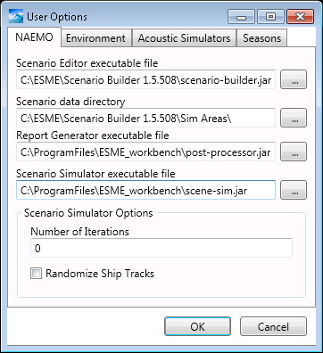

The Environment options link the ESME Workbench with the files in the OAML databases. The paths should be set as shown below. Note, the file locations will depend on the directory structure of the local computer. See chapter two.

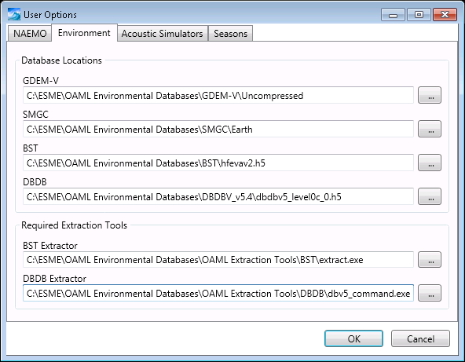

The default settings for the Acoustic Simulators (propagation models) and Seasons may be used, and will be assumed throughout the remainder of the user guide. There are four Acoustic simulators. The Bellhop model will be used in this user guide. The seasonal settings define the ocean sound speed profiles that will be used in the transmission loss calculations.

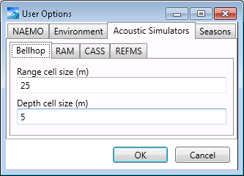 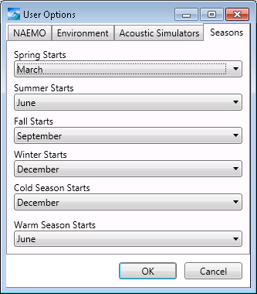

### Experiment File Name

When the ESME Workbench is opened, the default file name for the experiment is, “New experiment”. The file name appears within angle brackets at the top of the ESME Workbench window.

**NOTE:** An experiment cannot be saved until the options have been set and a scenario has been opened in the ESME Workbench.

To save the experiment, click on the applications menu button and select “Save Experiment As” from the drop-down list. The new file name will appear in angle brackets at the top of the ESME Workbench window. An experiment can be saved by selecting “Save Experiment” in the Application Menu, or pressing using either Control-S on the keyboard.

The experiment should be saved periodically. As a reminder, an asterisks will appear next to the file name when there are unsaved changes in the experiment.

## ESME Functionality

This section contains flow charts to provide an overall view how simulations are created and run in the ESME Workbench.

### ESME Overview

**ESME_overview.tif**

### Creating an Experiment

**ESME_experiment.tif**

### Running a Transmission Loss Analysis

**ESME_TL_analysis.tif**

### Running an Animat Scenario

**ESME_animat_scenario.tif**

# Chapter 4: Example Experiment

This section provides step-by-step instructions to create an experiment in the Atlantic ocean near Jacksonville, FL. It will use a .nemo file that was already created in Scenario Builder, and a .sce file previously created in 3MB. Both files were downloaded from the BU server in Chapter two.

## Load a scenario file

**NOTE:** An experiment cannot be saved until the options have been set and a scenario has been opened in the ESME Workbench.

Click “Open” in the Scenario section of the Experiment tab.



Select the JAX Small.nemo file in the \Scenario Builder.5.508\Jacksonville folder.

This file was created with the Scenario Builder and contains all of the sound source information for a simple scenario.

The map layers for two operating areas and ship tracks appear on the screen east of Florida. Zoom and/or pan to see the ship tracks as shown below. The width of the layers window can be expanded by clicking on the line between the layer and map windows and dragging the boundary line to the right.

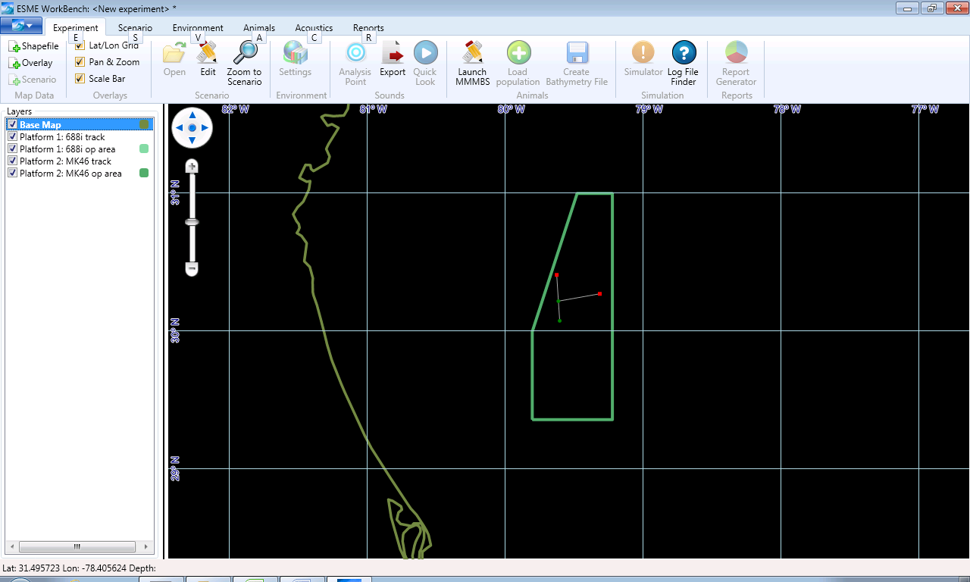

The operation areas are shown as overlapping green polygons. (In this example, the operating area for both platforms is the same). The display for each operating area can be turned on/off by checking/un-checking the box next to the “Platform 1: 688i op area” or “Platform 2: MK46 op area” in the Layers box to the left of the map.

The 688i track (Platform 1) runs along the gray line from South to North; beginning at the green circle and ending at the red square. Similarly, the MK46 track (Platform 2) runs along a horizontal gray line. The display for each track can be turned on/off by checking/un-checking the box next to the “Platform 1: 688i track” or “Platform 2: MK46 track” in the Layers box to the left of the map.

Note: Turning the map display for a track on/off does not impact the sources used in the TL calculations. The operating area and track displays only provide a guide when selecting analysis points for the TL calculations.

## Create an Experiment File Name

In the application menu, select “Save File As” and navigate to the Experiments directory (see Chp. 2). Enter a file name, e.g. Jacksonville\_example.esme, and click “Save”. The filename now appears at the top of the ESME Workbench window.

## Load an animal population from 3MB

Click on the Animals tab, and then click on “Load Population” as shown below.

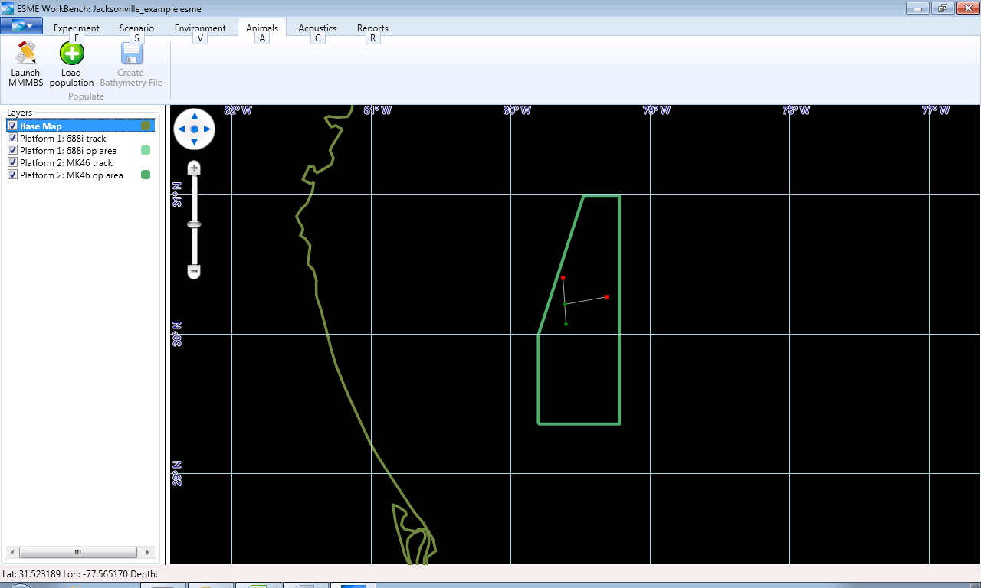

Set the path to the jax3species\_bathybounded.sce file in the \ESME\_data\_files folder. This file was created with 3MB and contains the marine mammal locations.

The random placements of 3 animat species appear on the map and are listed in the Layers box as shown below.

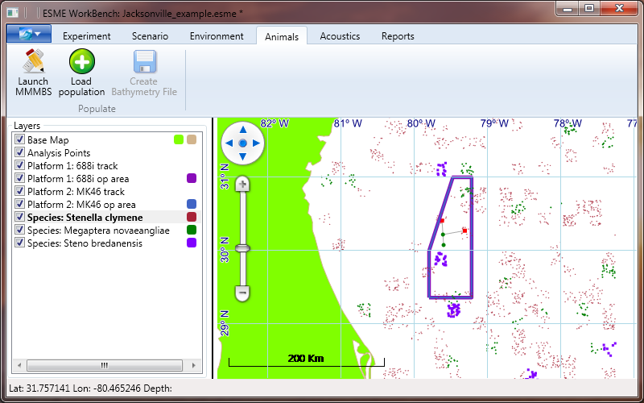

The display for each species can be turned on/off by checking/un-checking the box next to the species names in the Layers box to the left of the map.

The color and shape of the animat markers are assigned randomly for each species. The color, shape and size of the markers can be edited by right-clicking on the square to the right of the species name in the Layers box.

Save the experiment using either Control-S, or “Save Experiment” in the Application Menu.

Close the experiment. Select “Close Experiment” from the application menu in the upper left corner of the ESME window. The map window zooms out to the world map, and the Platform tracks and operating areas are removed from the display layers.

**Run a TL Analysis**

Open the experiment that was just created in the previous section:

Select “Open Experiment” from the application menu in the upper left corner of the ESME window

Navigate to the \ESME\_experiments folder, click on the Jacksonville\_example.esme file and click “Open”.

The map window zooms back to the last view that was used before the experiment was saved. The Platform tracks and operating areas are again visible as display layers. All the file path settings for the input data files are restored, and ESME Workbench is ready to run an analysis.

**Run a TL calculation at an Analysis Point:**

Click on the Experiment tab

Click on the Settings button in the Environment section of the Experiment tab. No changes are needed, but this window must be opened and closed to activate the Analysis Point or Quick Look buttons. This is a known bug to be fixed in future version. (Quick Look is not active in this release.)

Click on the Analysis Point button in the Sounds section of the Experiment tab. The mouse cursor now turns into a cross hair.

In the map window, click on a point near the end of the MK46 track (red square at the end of the gray horizontal line) as shown below.

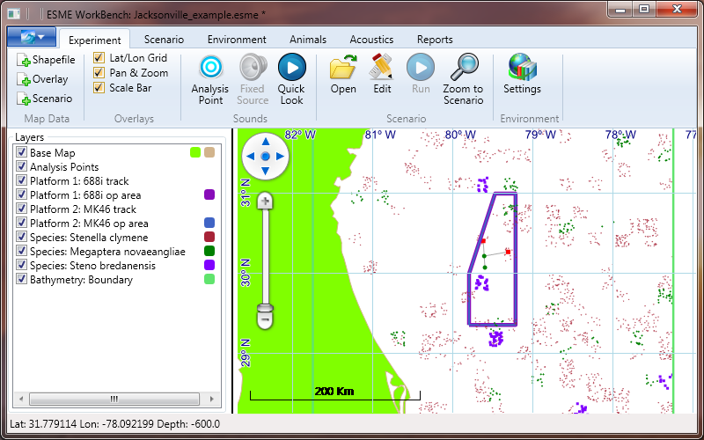

The Analysis Point View window opens up showing each of the modes for each platform in the experiment as shown below.

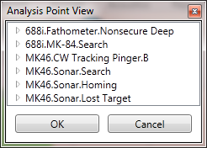

Double-click on the “688i.Fathometer.Nonsecure Deep” mode of the 688i platform to see the source settings that will be used.

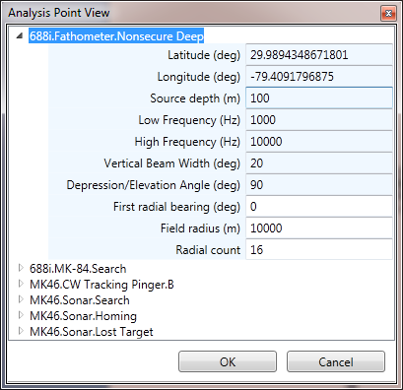

Settings that are in white may be edited. For this example, source settings will not be edited.

All of the modes for all of the platforms will be run at these coordinates. Future versions of ESME Workbench will allow more flexibility in selecting the active modes.

Double-Clicking on other modes will open their settings.

Double-Clicking on an open mode name will minimize the list of options for that mode.

Click “OK” to begin the TL calculations.

The Bellhop Queue Calculator View window opens.

The Queue window shows the TL calculation status of each of the modes.

Double-Click on the first mode to see the TL calculation status of each radial.

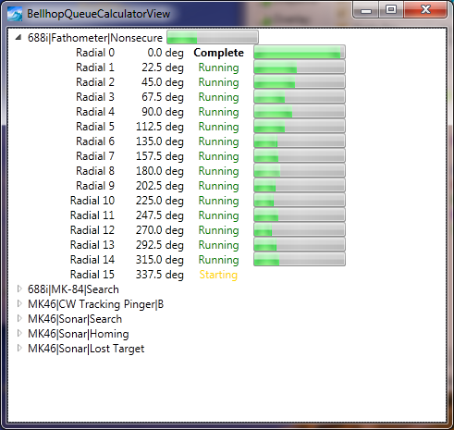

The mode name will disappear from the list when its TL calculations are finished.

The Queue window will close automatically when all of the calculations are finished.

Note: Do not close the Bellhop Queue Calculator window while the calculations are running. This will stop the calculations and cause ESME to become unstable. ESME will shut down when attempting to run another Quick Look calculation, unless ESME is restarted.

When the analysis is completed, the map window will show a green marker at the location of the sources, as shown below.

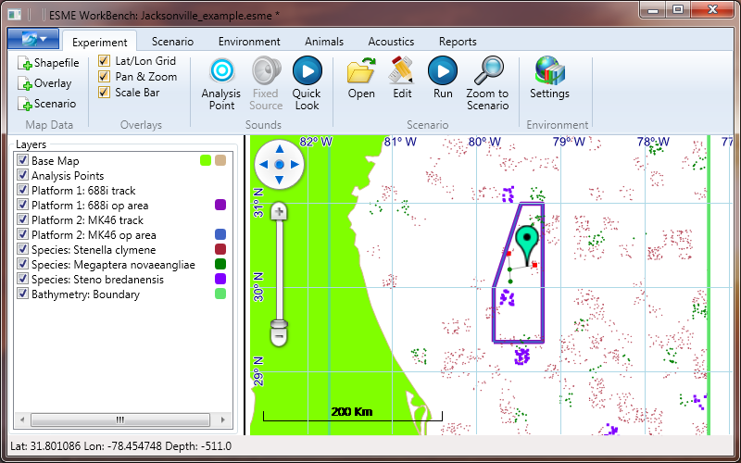

Save the experiment using either Control-S, or “Save Experiment” in the Application Menu.

**Plot the TL**

Right click on the quick look analysis point (the green marker on the map), and select “View…”.

A window opens showing a vertical plot of the TL for the first radial of the first mode, as shown below.

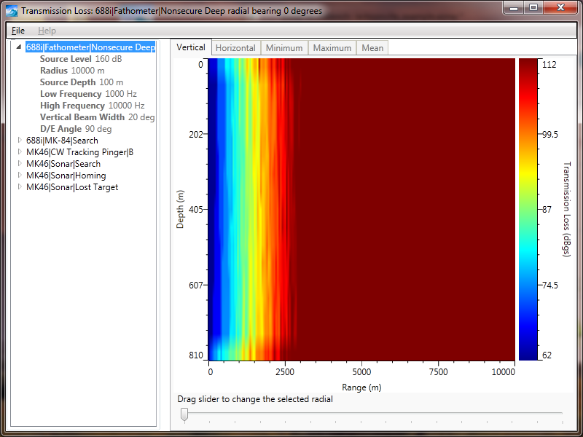

The TL for the other radials can be selected by dragging the slider at the bottom of the window to one of the 16 markers. The radial bearing is displayed at the top of the window.

The color bar is scaled automatically for each transect.

Other modes can be selected in the left pane of the window, and the vertical TL plots for each radial can be viewed in a similar manner.

The source parameters can be viewed by clicking on the triangle to the left of the mode name.

The Horizontal, Minimum, Maximum and Mean tabs are not active in the current version of ESME.

To save the plot, click File, “Save As” or Ctrl-S. The default format is .png.

The TL values at each range and depth can be exported to a .csv file, by clicking File, “Export to csv” or Ctrl-E.

An example of the output file is shown below.

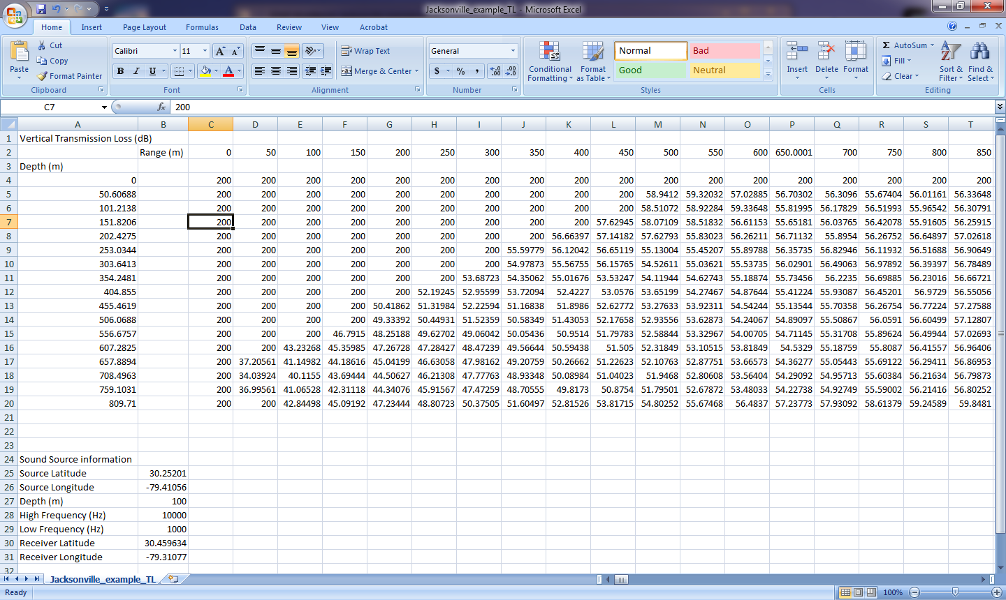

**Run an Animat Scenario**

Click on the “Run” button in the Scenario section of the Experiment tab, as shown below.



The Simulation View window opens, as shown below.

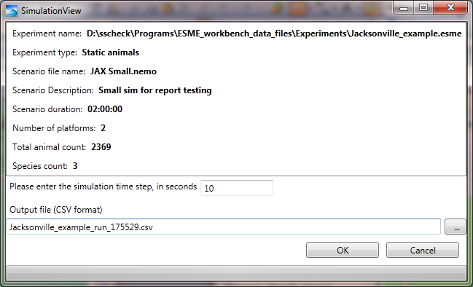

Set the simulation time step to 10.

The filename is populated automatically. (The run number may not be the same as the one shown here.)

Click on the “…” button in the lower right corner, and set the path for the output file to the experiments directory. (Otherwise, the default directory is the ESME program directory.)

Click OK.

A green status bar begins to fill up along the bottom of the window, as the analysis runs, as shown below.

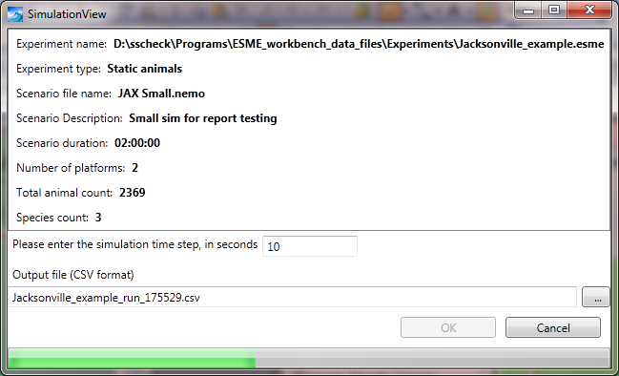

Simulation Status

Save the experiment:

Save the experiment using either Control-S, or the Application Menu.

Close the experiment

Select “Close Experiment” from the application menu in the upper left corner of the ESME window. The map window zooms out to the world map, and the Platform tracks and operating areas are removed from the display layers.

Exit ESME. Select “EXIT” from the from the application menu in the upper left corner of the ESME window.

**View the results of the animat simulation**

Open the .csv file.

Open Excel and then open the .csv file, and view the results, as shown below.

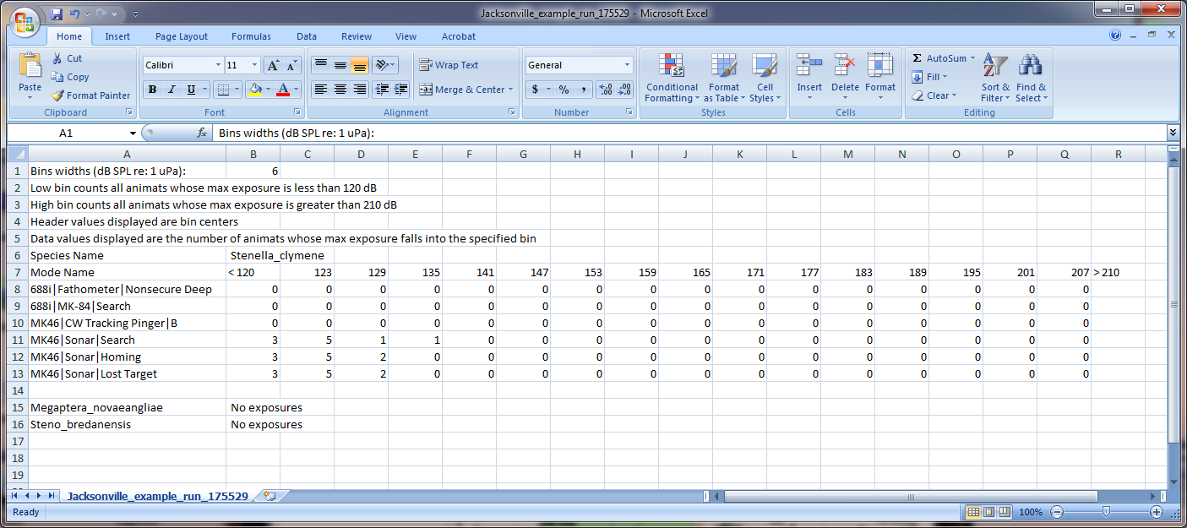

# Bibliography

Collins, M.D., Cederberg, R.J., King, D.B., Chin-Bing, S.A. "Comparison of algorithms for solving parabolic wave equations." *Journal of the Acoustic Society of America* 100, no. 1 (July 1996): 178-182.

Gisiner, R., Harper, S., Livingston, E. and Simmen, J. "Effects of Sound on the Marine Environment (ESME): An Underwater Noise Risk Model." *IEEE Journal of Oceanic Engineering* 31 (January 2006): 4-7.

Houser, D. S. "A method for modeling marine mammal movement and behavior for environmental impact assessment." *IEEE Journal of Oceanic Engineering* 31 (January 2006): 76-81.

Keenan, R.E. "An Introduction to GRAB Eigenrays and CASS Reverberation and Signal Excess." *IEEE Oceans Conference.* Providence, RI, USA: IEEE, 2000. 1065-1070.

Navy, U.S. Department of the. *Hawaii Range Complex, Final Environmental Impact Statement/Overseas Environmental Impact Statement.* Washington, DC: U.S. Department of the Navy, 2008.

Porter, M.B. "Gaussian beam tracing for computing ocean acoustic fields." *Journal of the Acoustic Society of America* 2, no. 84 (1987): 1349-1359.

Shyu, H-J. and Hillson, R. "A Software Workbench for Estimating the Effects of Cumulative Sound Exposure in Marine Mammals." *IEEE Journal of Oceanic Engineering* 31 (January 2006): 8-21.